



LAB MANUAL
DBMS

Disclaimer: The content is curated from online/offline resources and used for educational purpose only
Longest Repeating Substring using Dynamic Programming

Objective:
To implement a Dynamic Programming (DP) approach in Python to find the longest repeating substring in a given string.

Problem Statement:
- Given a string `s`, find the longest repeating substring using dynamic programming.
- A repeating substring is a substring that appears more than once in the string without overlapping.

Equipment Required:
- A computer with:
  - Python 3.x installed
  - Jupyter Notebook (Anaconda or via pip install)
- Any code editor (optional)
- Internet (for further references)

Prerequisites:
- Basic understanding of Python programming
- Understanding of strings and string manipulation
- Familiarity with the concept of Dynamic Programming

Procedure:
Step 1: Define the Input String
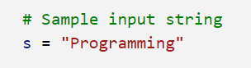

Step 2: Initialize the DP Table
- We use a 2D table where `dp[i][j]` stores the length of the longest common suffix of substrings `s[0…i-1]` and `s[0…j-1]`.
- Ensure that `i != j` to avoid overlapping substrings.

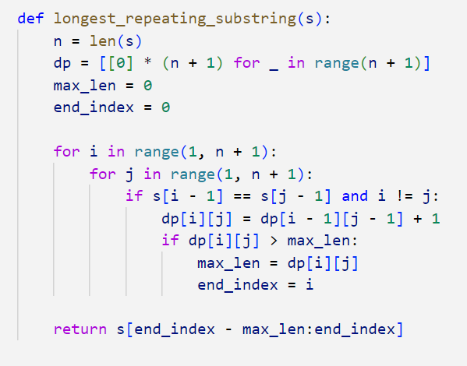

Step 3: Call the Function and Display the Result

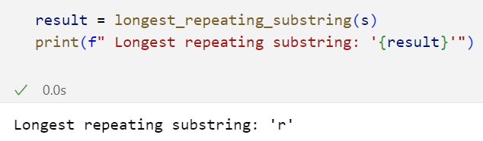

Conclusion
In this lab, we:
- Used Dynamic Programming to solve a string problem
- Built and used a 2D DP table to track common suffixes
- Efficiently identified the longest repeating substring in the given input

